|  |
| --- |
| **NUCL 355 Experiment 12** |
| Pool Boiling  Professor M. Bertandano |
|  |
| School of Nuclear Engineering  Purdue University  Report of the Experiment By:  Weston Cundiff, Stephen Cox, Kara Luitjohan, Patrick Burk, Dominic Ghering, Michael Stryker, Austin Curtis, Matt Metzger, et. Al. |
| **Written By Alex Hagen** |
| **4/19/2011** |
|  |

# Introduction and Theory

Pool Boiling and Critical Heat Flux are important phenomena in the industrial world. Not only is it important to avoid critical heat flux within metal systems that have the possibility of melting, but it is important to understand the pool boiling curve for many thermodynamic systems. The pool boiling curve is shown below, with the unstable region shown dashed.

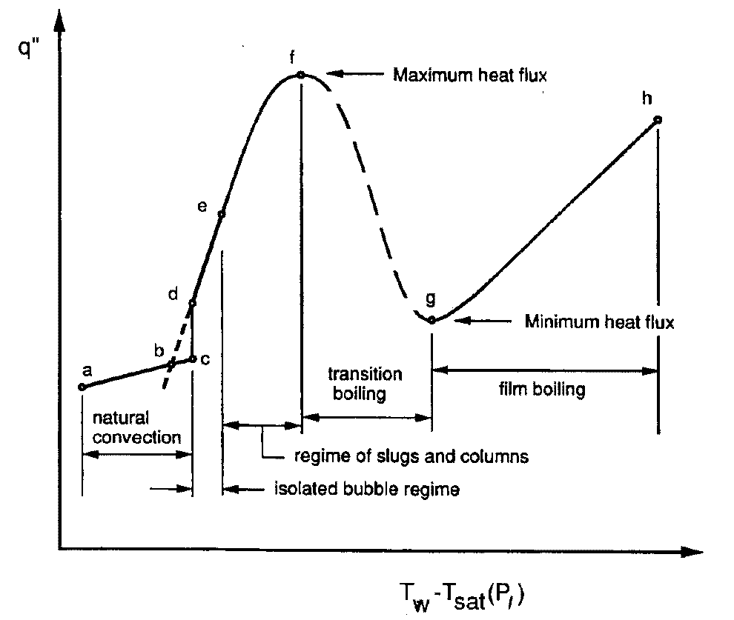

Figure .1 Pool Boiling Curve

Critical heat flux would occur at the top of the first hump, and would skip the entire unstable region, allowing the increase of heat flux to continue. When this occurs, there is very little convection to cool the metal, and it will start to melt. This experiment is designed to show this phenomenon.

A wire creates heat through the resistance in a wire, and the power created is given by Ohms Law. This relationship is shown below.

$$\frac{P}{A}=q^{''}=\frac{IV}{2πD*L}$$

The only components in the system as it is modeled for the experiment are convection and the energy generation within the wire. Because of this, the heat transfer coefficient can be calculated solely by the temperature of the wire. The temperature of the wire can be found by the relationship between electrical resistance and temperature within tungsten. This relationship is approximately linear, and thus can give temperatures at extrapolated values. The relationship between heat flux and the heat transfer coefficient is shown below.

$$q^{''}=h\left(T_{wall}-T_{b}\right)$$

Zuber created an analytical estimation of the critical heat flux through many experiments. This is the most accurate model to date, and is often used to estimate the CHF in industrial situations. The equation deals with the nucleate boiling that occurs before CHF, and is given below.

$$q_{chf}^{''}=c_{cr}h_{fg}ρ_{v}{\left[σg\frac{\left(ρ_{l}-ρ_{v}\right)}{ρ_{v}^{2}}\right]}^{.25}$$

# Analysis and Discussion of Data

In the analysis of the data taken in a Critical Heat Flux, there is an important process that must be taken to thoroughly analyze the data taken. This process takes that data through the process of pool boiling, from the initial voltage and amperage and visual cues. After the initial data is taken, it must be turned into the heat flux throughout the process. This can be related to the convection to the water, and thus can provide the heat transfer coefficient. Also, using Zuber’s critical heat flux equation, the value for heat flux at the final value of the burnout can be compared to an analytical solution.

An important parameter and correlation within this experiment is the wall temperature of the wire against the power provided to the wire. This temperature will define the convection. Using the resitivity of the wire against the temperature for tungsten, a correlation can be found for the resistance per unit length against the temperature. This is done in the sample calculations. This linear relationship gives the temperature from the resistance per unit length. Because the length does not change, the resistance can be calculated using the voltage and the current. This relationship is shown below.

Figure .1 Wall Temperature vs. Power

This shows that the temperature of the wall reaches a critical point and does not change significantly, because of the playing of the resistance against the linear relationship with temperature. The error values in this correlation are very small, showing that this is a very accurate relationship.

Before critical heat flux, an energy balance can be completed to determine the convection out of the system. This convection goes entirely to the water. Because of latent heat and the constant temperature of boiling water, the heat transfer coefficient can be calculated using the saturation temperature for water. This correlation is shown below.

Figure .2 Heat Transfer Coefficient vs. Power

It is shown that as the power increases, the heat transfer coefficient also increases. This follows the trend that is expected, from the pool boiling curve. From the pool boiling curve, the initial heat transfer coefficient should be near zero, and should then increase. When it reaches to the top of that first hump of the curve, in the case of this experiment, it will continue increasing as critical heat flux is reached.

This critical heat flux is a difficult phenomenon to model, but Zuber’s experimentally obtained model is often used for this phenomenon, shown below. The data from the burnout on the wire closely matches the data obtained using Zuber’s CHF equation, showing the validity of the model.

$$q_{chf}^{''}=c_{cr}h_{fg}ρ_{v}{\left[σg\frac{\left(ρ_{l}-ρ_{v}\right)}{ρ_{v}^{2}}\right]}^{.25}=\left(0.149\right)\left(1225000\frac{J}{kg}\right)\left(0.5959\frac{kg}{m^{3}}\right){\left[\frac{\left(58.9*{10}^{-3}\frac{N}{m}\right)\left(9.81\frac{m}{s^{2}}\right)\left((1000\frac{kg}{m^{3}}-0.5959\frac{kg}{m^{3}}\right)}{{\left(0.5959\frac{kg}{m^{3}}\right)}^{2}}\right]}^{.25}=690701.52\frac{W}{m^{2}K}$$

## Error

The wall temperature in this experiment was defined using a correlation between data that had to be extrapolated out several orders of magnitude, and may break down. Other than that, error analysis is straightforward. Error analysis using the method of partial derivatives has been documented through the sample calculations and listed in all tables. Values labeled uvalue are these error values (THESE ARE QUANTITATIVE ERROR).

## Recommendations

Data acquisition software would create a better setup to take data after burnout when the power surge was used. Without this, no valid data was able to be taken by the group because of the high speed of the data acquisition needed.

# Conclusions

The use of this experiment has lead to several conclusions about the pool boiling curve, and in particular critical heat flux. These conclusions have to do with the temperature of a tungsten wire, as well as with the heat transfer coefficients and how those coefficients match up to mathematical models. These conclusions have been shown extensively through data.

The temperature of a tungsten wire will reach steady state when power is passed through the wire because of the convection occurring into the water. This will stay this way until critical heat flux is reached, where the temperature will increase to the melting point of tungsten. The temperature of tungsten in this experiment started at 6.37 million ± .0313 degrees Celsius and increased to nearly 7.6 million ± .0349 degrees Celsius, with the steady state temperature occurring at about 7.41 million ± .0313 degrees Celsius.

The heat transfer coefficient should increase as the power in the wire is increased until a certain point where it will reach the unstable region. When it reaches this unstable region, if going into CHF, it should continue increasing, this time faster. The initial increase of heat transfer coefficient was found in this model, and is shown in the chart in data analysis. This increase occurred from 0.0000450 ± .0000746 W/m2K all the way up to .0939 ± .0175 W/m2K.

The maximum value of heat flux in our experiment will correlate with the heat flux needed for critical heat flux. Zuber’s correlation is a good way of calculating an analytical value for the Critical heat flux. The highest value of heat flux in the experiment was 695353.31 ± 9.96 W/m2K, and this correlated well with the value calculated from Zuber’s correlation at 690701.52 W/m2K. This shows that the data collected shows very accurate data.

# Works Cited

Munson, Y. O. (2009). *Fundamentals of Fluid Mechanics.* Hoboken, NJ: Wiley and Sons, Inc.

Revankar, S. (2011). *Experiment #12: Pool Boiling.* West Lafayette, IN: Purdue University School of Nuclear Engineering.

Wolfram Alpha LLC. (2011). *Wolfram|Alpha: Computational Knowledge Engine*. Retrieved 2011, from Wolfram Alpha: http://www.wolframalpha.com

# Appendices

## Original Data

|  |  |  |
| --- | --- | --- |
|  | Current | Voltage |
|  | 1.54 | 0.040 |
|  | 3.60 | 0.10 |
|  | 6.55 | 0.20 |
|  | 9.85 | 0.30 |
|  | 13.05 | 0.40 |
|  | 15.43 | 0.50 |
|  | 17.75 | 0.55 |
|  | 22.47 | 0.65 |
|  | 23.70 | 0.75 |
|  | 26.65 | 0.85 |
|  | 33.70 | 0.95 |
|  | 39.65 | 1.15 |
|  | 44.60 | 1.35 |
|  | 49.63 | 1.50 |
|  | 53.30 | 1.60 |
|  | 56.30 | 1.75 |
|  | 60.00 | 1.75 |
|  | 63.15 | 1.90 |
|  | 65.77 | 2.00 |
|  | 66.45 | 2.05 |
|  | 68.50 | 2.10 |
|  | 70.65 | 2.15 |
| BURNOUT | **72.80** | **2.20** |

Table .1 Q'' Data for Sample 1

|  |  |  |
| --- | --- | --- |
|  | Current | Voltage |
|  | 1.70 | 0.050 |
|  | 5.70 | 0.20 |
|  | 12.40 | 0.41 |
|  | 18.90 | 0.60 |
|  | 24.90 | 0.75 |
|  | 33.40 | 0.95 |
|  | 42.20 | 1.25 |
|  | 50.20 | 1.50 |
|  | 60.90 | 1.80 |
|  | 64.40 | 1.95 |
|  |  |  |
| AFTER SURGE | 58.6 |  |
|  | 29.8 |  |

Table .2 Q Data for Sample 2

## Reduced Data

|  |  |  |  |  |  |  |  |  |
| --- | --- | --- | --- | --- | --- | --- | --- | --- |
| Current | Voltage | Power (W/m^2) | Power Error (W/m^2) | Electrical Resistivity (microohms * cm) | Temperature of Wall (^o C) | Temperature of Wall Error (^o C) | Heat Transfer Coefficient (W/m^2 K) | Heat Transfer Coefficient Error (W/m^2 K) |
| 1.54 | 0.040 | 267.44 | 10.27 | 187432.21 | 6.37E+06 | 3.13E-02 | 4.20E-05 | 7.45E-06 |
| 3.60 | 0.10 | 1562.98 | 10.01 | 200448.33 | 6.81E+06 | 3.23E-02 | 2.30E-04 | 4.12E-05 |
| 6.55 | 0.20 | 5687.52 | 9.97 | 220340.15 | 7.48E+06 | 3.53E-02 | 7.60E-04 | 1.43E-04 |
| 9.85 | 0.30 | 12829.48 | 9.96 | 219780.91 | 7.47E+06 | 3.52E-02 | 1.72E-03 | 3.22E-04 |
| 13.05 | 0.40 | 22663.24 | 9.96 | 221184.37 | 7.51E+06 | 3.54E-02 | 3.02E-03 | 5.67E-04 |
| 15.43 | 0.50 | 33502.81 | 9.96 | 233784.23 | 7.94E+06 | 3.74E-02 | 4.22E-03 | 8.16E-04 |
| 17.75 | 0.55 | 42385.03 | 9.96 | 223598.70 | 7.59E+06 | 3.58E-02 | 5.58E-03 | 1.06E-03 |
| 22.47 | 0.65 | 63402.07 | 9.96 | 208775.56 | 7.09E+06 | 3.34E-02 | 8.94E-03 | 1.63E-03 |
| 23.70 | 0.75 | 77172.24 | 9.96 | 228358.86 | 7.76E+06 | 3.65E-02 | 9.95E-03 | 1.90E-03 |
| 26.80 | 0.85 | 98902.03 | 9.96 | 228870.11 | 7.77E+06 | 3.66E-02 | 1.27E-02 | 2.43E-03 |
| 33.70 | 0.95 | 138996.86 | 9.96 | 203422.34 | 6.91E+06 | 3.25E-02 | 2.01E-02 | 3.63E-03 |
| 39.65 | 1.15 | 197966.86 | 9.96 | 209295.36 | 7.11E+06 | 3.35E-02 | 2.78E-02 | 5.09E-03 |
| 44.60 | 1.35 | 261408.74 | 9.96 | 218425.76 | 7.42E+06 | 3.49E-02 | 3.52E-02 | 6.58E-03 |
| 49.63 | 1.50 | 323233.36 | 9.96 | 218083.48 | 7.41E+06 | 3.49E-02 | 4.36E-02 | 8.15E-03 |
| 53.30 | 1.60 | 370253.06 | 9.96 | 216619.59 | 7.36E+06 | 3.46E-02 | 5.03E-02 | 9.36E-03 |
| 56.30 | 1.75 | 427757.78 | 9.96 | 224302.75 | 7.62E+06 | 3.59E-02 | 5.61E-02 | 1.06E-02 |
| 60.00 | 1.75 | 455869.74 | 9.96 | 210470.75 | 7.15E+06 | 3.36E-02 | 6.38E-02 | 1.17E-02 |
| 63.15 | 1.90 | 520928.87 | 9.96 | 217112.68 | 7.37E+06 | 3.47E-02 | 7.06E-02 | 1.32E-02 |
| 65.77 | 2.00 | 571067.30 | 9.96 | 219446.73 | 7.45E+06 | 3.51E-02 | 7.66E-02 | 1.43E-02 |
| 66.45 | 2.05 | 591425.87 | 9.96 | 222619.82 | 7.56E+06 | 3.56E-02 | 7.82E-02 | 1.48E-02 |
| 68.50 | 2.10 | 624541.55 | 9.96 | 221224.73 | 7.51E+06 | 3.54E-02 | 8.31E-02 | 1.56E-02 |
| 70.65 | 2.15 | 659480.71 | 9.96 | 219599.45 | 7.46E+06 | 3.51E-02 | 8.84E-02 | 1.66E-02 |
| 72.80 | **2.20** | **695353.31** | **9.96** | **218070.16** | **7.41E+06** | **3.49E-02** | **9.39E-02** | **1.75E-02** |

Table .3 Sample 1 Data

|  |  |  |  |  |  |  |  |  |
| --- | --- | --- | --- | --- | --- | --- | --- | --- |
| Current | Voltage | Power (W/m^2) | Power Error (W/m^2) | Electrical Resistivity (microohms * cm) | Temperature of Wall (^o C) | Temperature of Wall Error (^o C) | Heat Transfer Coefficient (W/m^2 K) | Heat Transfer Coefficient Error (W/m^2 K) |
| 1.70 | 0.050 | 369.04 | 10.15 | 212239.41 | 7.21E+06 | 3.49E-02 | 5.12E-05 | 9.57E-06 |
| 5.70 | 0.20 | 4949.44 | 9.97 | 253197.89 | 8.60E+06 | 4.05E-02 | 5.76E-04 | 1.16E-04 |
| 12.40 | 0.41 | 22072.78 | 9.96 | 238598.18 | 8.10E+06 | 3.82E-02 | 2.72E-03 | 5.32E-04 |
| 18.90 | 0.60 | 49233.93 | 9.96 | 229083.81 | 7.78E+06 | 3.66E-02 | 6.33E-03 | 1.21E-03 |
| 24.90 | 0.75 | 81079.69 | 9.96 | 217353.61 | 7.38E+06 | 3.47E-02 | 1.10E-02 | 2.05E-03 |
| 33.40 | 0.95 | 137759.49 | 9.96 | 205249.49 | 6.97E+06 | 3.28E-02 | 1.98E-02 | 3.58E-03 |
| 42.20 | 1.25 | 229020.28 | 9.96 | 213748.22 | 7.26E+06 | 3.42E-02 | 3.15E-02 | 5.83E-03 |
| 50.20 | 1.50 | 326923.73 | 9.96 | 215621.71 | 7.32E+06 | 3.45E-02 | 4.46E-02 | 8.29E-03 |
| 60.90 | 1.80 | 475928.01 | 9.96 | 213284.93 | 7.24E+06 | 3.41E-02 | 6.57E-02 | 1.21E-02 |
| 64.40 | 1.95 | 545220.21 | 9.96 | 218501.13 | 7.42E+06 | 3.49E-02 | 7.35E-02 | 1.37E-02 |
| 58.6 | 1.95 | 496116.53 | 9.96 | 240127.53 | 8.16E+06 | 3.84E-02 | 6.08E-02 | 1.19E-02 |
| 29.8 | 1.95 | 252291.34 | 9.96 | 472197.08 | 1.60E+07 | 7.55E-02 | 1.57E-02 | 4.32E-03 |

Table . Sample 2 Data

## Sample Calculations

### Power

$$\frac{P}{A}=q^{''}=\frac{IV}{2πD*L}=\frac{\left(1.54 A\right)\left(0.04 V\right)}{2π\left(0.000508 m\right)(0.0722 m)}=267.30\frac{W}{m^{2}}$$

### Power Error

$$u_{P}=\frac{1}{q''}\sqrt{{\left(\frac{V}{2πD*L}\right)}^{2}u_{I}+{\left(\frac{I}{2πD*L}\right)}^{2}u_{V}+{\left(\frac{IV}{2πD^{2}*L}\right)}^{2}u_{D}+{\left(\frac{IV}{2πD*L^{2}}\right)}^{2}u_{L}}=\frac{1}{267.30\frac{W}{m^{2}}}{\left({\left(\frac{\left(0.04 V\right)}{2π\left(0.000508 m\right)*\left(0.0722 m\right)}\right)}^{2}(.01 A)+{\left(\frac{\left(1.54 A\right)}{2π\left(0.000508 m\right)*\left(0.0722 m\right)}\right)}^{2}(.01 V)+{\left(\frac{\left(1.54 A\right)\left(0.04 V\right)}{2π{\left(0.000508 m\right)}^{2}*\left(0.0722 m\right)}\right)}^{2}(.000002554 m)+{\left(\frac{\left(1.54 A\right)\left(0.04 V\right)}{2π\left(0.000508 m\right)*L^{2}}\right)}^{2}(.00361 m)\right)}^{\frac{1}{2}}=10.27\frac{W}{m^{2}}$$

### Temperature of Wall

Electrical Resistivity and Temperature has an almost linear fit, so it can be estimated as linear.

$$T=\left(33.9673\right)\left(\frac{\frac{40000 μV}{1.54 A}}{7.22 cm}\right)-{132.4461}^{o}C=6.37*{10}^{6} ^{o}C$$

### Error in Temperature of Wall

$$u_{T}=\sqrt{{\left(\frac{1}{IL}\right)}^{2}u_{V}+{\left(\frac{V}{I^{2}L}\right)}^{2}u_{I}+{\left(\frac{V}{IL^{2}}\right)}^{2}u_{L}}={\left({\left(\frac{1}{\left(1.54 A\right)\left(7.22 cm\right)}\right)}^{2}\left(.01 V\right)+{\left(\frac{\left(40000 μV\right)}{{\left(1.54 A\right)}^{2}\left(7.22 cm\right)}\right)}^{2}\left(.01 A\right)+{\left(\frac{\left(40000 μV\right)}{\left(1.54 A\right){\left(7.22 cm\right)}^{2}}\right)}^{2}\left(.361 cm\right)\right)}^{\frac{1}{2}}=3.13*{10}^{-2} ^{o}C$$

### Heat Transfer Coefficient

$$q^{''}=h\left(T_{wall}-T_{b}\right)$$

$$h=\frac{q^{''}}{T_{wall}-T_{b}}=\frac{267.30\frac{W}{m^{2}}}{6.37*{10}^{6} ^{o}C-{100}^{o}C}=4.20*{10}^{-5}\frac{W}{m^{2}K}$$

### Error in Heat Transfer Coefficient

$$u_{h}=\sqrt{{\left(\frac{1}{T_{wall}-T_{b}}\right)}^{2}u_{q^{''}}+{\left(\frac{q^{''}}{{\left(T_{wall}-T_{b}\right)}^{2}}\right)}^{2}u_{T_{wall}} }=\sqrt{{\left(\frac{1}{(6.37*{10}^{6} ^{o}C)-({100}^{o}C)}\right)}^{2}10.27\frac{W}{m^{2}}+{\left(\frac{267.30\frac{W}{m^{2}}}{{\left((6.37*{10}^{6} ^{o}C)-({100}^{o}C)\right)}^{2}}\right)}^{2}3.13*{10}^{-2} ^{o}C }=7.455*{10}^{-6}\frac{W}{m^{2}K}$$

### CHF

CHF is the heat and transfer coefficient (and q’’) at burnout: Thus chf in this experiment is 695353.31 W/m^2, with a heat transfer coefficient of .0939 W/m^2 K.

### Zuber’s Correlation

$$q_{chf}^{''}=c_{cr}h_{fg}ρ_{v}{\left[σg\frac{\left(ρ_{l}-ρ_{v}\right)}{ρ_{v}^{2}}\right]}^{.25}=\left(0.149\right)\left(1225000\frac{J}{kg}\right)\left(0.5959\frac{kg}{m^{3}}\right){\left[\frac{\left(58.9*{10}^{-3}\frac{N}{m}\right)\left(9.81\frac{m}{s^{2}}\right)\left((1000\frac{kg}{m^{3}}-0.5959\frac{kg}{m^{3}}\right)}{{\left(0.5959\frac{kg}{m^{3}}\right)}^{2}}\right]}^{.25}=690701.52\frac{W}{m^{2}K}$$